A Book, a Song, and a Story that Still Matters
More than two decades have passed, but Peggy Turnipseed can still picture the moment. Peggy, former Chair of the Lutheran Braille Workers Board of Directors and current leader of Ministry Production Center #146, has been part of countless moments
of ministry through LBW. But when asked recently about one of the memories that has stayed with her most, her thoughts traveled back to December 2004 and the World Blind Union Conference in Cape Town, South Africa.
While representing LBW at the conference, Peggy had the opportunity to place a Large Print book of the Bible into the hands of a man with albinism. “There are no words to describe his joy at receiving his own ‘Book,’ “ Peggy remembers. But another encounter from that conference would leave an equally lasting impression.
A teacher stopped at the LBW booth, and Peggy and the team were able to give her a book for one of her blind students. They might never have known what that simple gift meant if the story had ended there. But the next day, the student arrived at the LBW booth with his mother and grandmother. They had come simply to say thank you and to sign up to receive additional books.
His name was Renier. Peggy’s handwritten notes from that trip preserve a few details about the young boy
in the orange shirt: He sings. He says Bible verses. He wants to be a singing preacher. And then Renier sang for them. He chose “You Raise Me Up.”
More than 20 years later, Peggy still wonders about that little boy. Where is Renier today? Did he become a preacher? Is he still singing? Did he continue receiving Christian materials in a format he could read? How did having access to God’s Word shape the person he became? “Wouldn’t that be a story!” Peggy says.
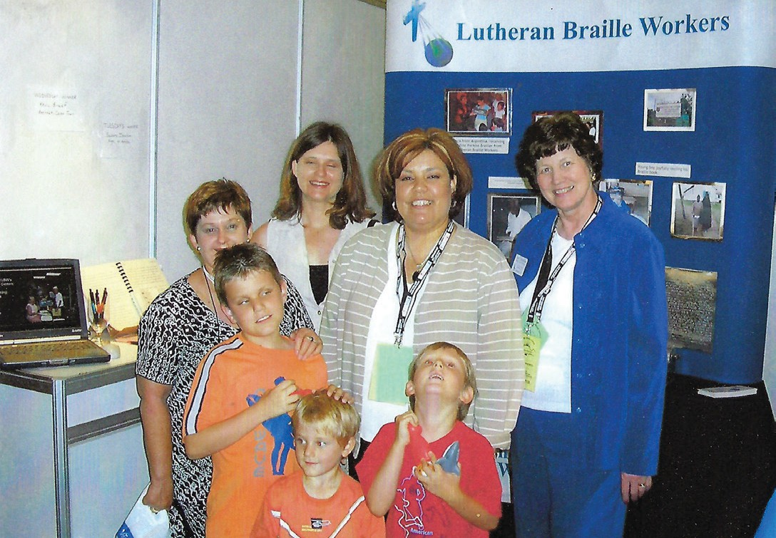
The photograph Peggy saved from that day shows Renier standing at the Lutheran Braille Workers booth, surrounded by some of the people who had gathered there. It captures one moment in time, but it also captures something much bigger about this ministry. At LBW, we often talk about numbers: books produced, volumes shipped, countries
reached, volunteers serving. Those numbers matter, but behind every number is a person—a child who wants to become a singing preacher, a mother and grandmother who make a special trip back just to say thank you, or a man holding his own Large Print
book of Scripture with a joy that, even decades later, is difficult to put into words.
That is one of the extraordinary things about sharing God’s Word: we rarely get to see the whole story.
story continued on page 3






ILLUMINATIONS
Sharing the Gospel Always
p.2 Hart for the Mission
p.4 Holiday Schedule
p.8 Ministry Updates
p.10 President’s Challenge
Fall 2026
PO Box 5000, Yucaipa, CA 92399 | 800-925-6092 | www.LBWloveworks.org

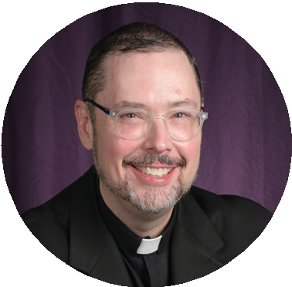


President (Rev. Dr.) Robert Hartwell

As autumn has arrived in the Northern Hemisphere and spring began in the Southern Hemisphere, we have seen changes taking place all around us. In some places, trees turn beautiful shades of gold, red, and orange or blossom. In others, the changes are more subtle as the weather shifts and daily routines change. At times, seasonal changes also bring storms that threaten lives and property. Wherever we live, these changes remind us that our powerful God is in control and that our lives are guided by His wisdom and care.
While the world around us is constantly changing, God never changes. The Bible tells us, “Jesus Christ is the same yesterday and today and forever” (Hebrews 13:8). Seasons come and go, years pass, and circumstances change, but God’s faithfulness remains constant. His love never fails, His promises are sure, and His presence gives us strength and hope. Through every season of life, He continues to guide and sustain His people. The life, death, and resurrection of Jesus Christ are the firm foundation of our faith, and His love, shown throughout history, remains with us forever.
We see this truth reflected in the ministry of Lutheran Braille Workers. By God’s grace and through the faithful service of volunteers, staff, donors, and supporters, His Word continues to reach people who are blind or visually impaired around the world. Every Braille book, large-print publication, and audio player provided free of charge shares the life-changing message of Christ. These are more than resources—they are expressions of God’s love and reminders
of the power of His Word, reaching people across languages, cultures, generations, and nations.
As we thank God for His faithfulness, we can also be grateful for the opportunity to take part in His work. Lutheran Braille Workers continues because
God sustains it and because He works through the generosity and dedication of His people. Through donors, volunteers, and staff, God uses people, like you and me, to do extraordinary things, bringing hope, encouragement, and the saving Gospel of Jesus Christ to thousands around the world.
September 1, 2026, marked the first anniversary of my service as president of Lutheran Braille Workers.
Although I have long loved this ministry, during the past year I have been blessed to meet many
wonderful individuals who share a deep commitment to its mission, both sighted and blind or low vision.
As a result, I believe more strongly than ever in the importance—the absolutely vital nature—of this ministry as a part pf God’s kingdom on earth.
God has demonstrated His love for us through Christ Jesus and continues to work in our lives through the power of the Holy Spirit. May this season encourage us to trust more fully in the God who holds every season of life in His hands and to renew our commitment to the work He has given us. May the God who orders all creation continue to bless this ministry. Through His faithfulness, the light of His Word continues to change lives and reminds us that while seasons change, His truth, His love, and His promises remain forever.
President Hartwell

Prayer
Precious God of Grace, thank You for Your unchanging love and faithfulness. As we experience change around us, help us to rest in the certainty of Your promises. Bless the ministry of Lutheran Braille Workers, its volunteers, supporters, and all who receive Your Word through its efforts. Continue to use this work to share the hope of Christ throughout the world. In Jesus’ name, Amen.

page 2

Cover Story Continued
page 3

A volunteer may spend an afternoon producing a book and never meet the person who will read it. A donor may provide the funds to send Scripture across the world without ever knowing whose hands will hold
it. Someone may pack a box, bind a volume, or place a book on a table and never see what God does with that gift five, ten, or twenty years later. The work that happens in a Ministry Production Center or at LBW headquarters can feel far removed from the person who ultimately receives it, but Peggy’s memory of Renier is a beautiful reminder that there is always someone at the other end of that work.
Peggy may never know exactly where Renier’s story led after that December day in Cape Town. Yet she knows that, for at least one moment, a young boy who loved to sing and recite Bible verses had greater access to the Word of God. Perhaps that is why, after all these years, she still remembers him so clearly.
Sometimes we are blessed to see the moment the book is placed into someone’s hands. The rest of the story, we entrust to God.

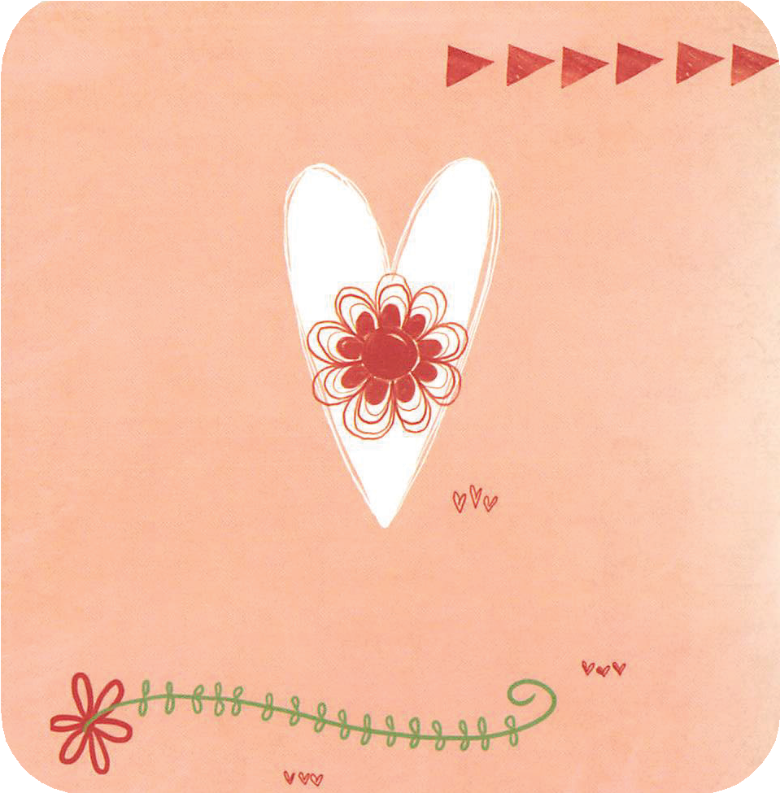
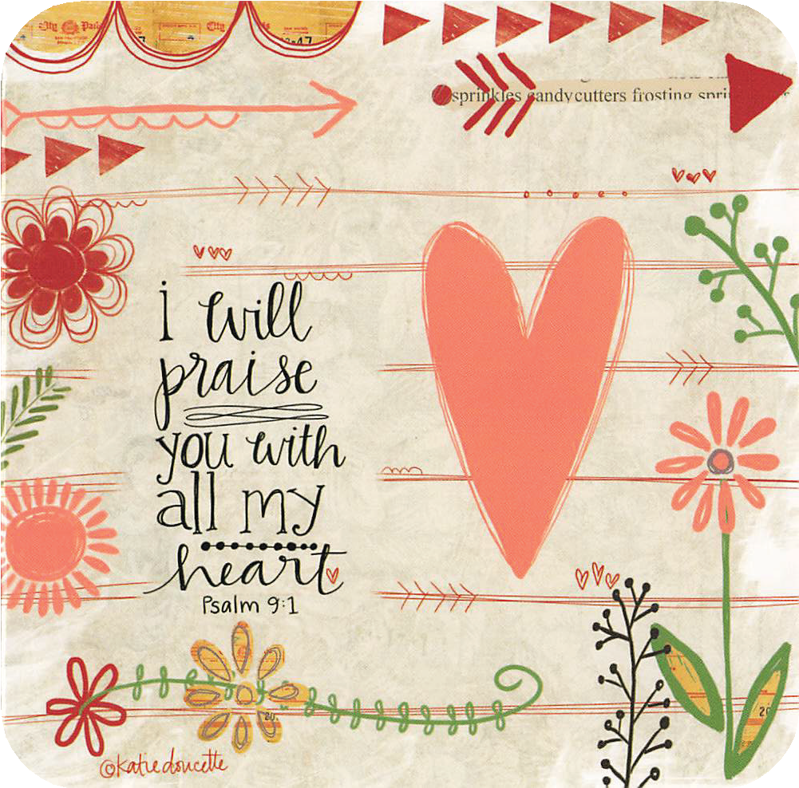
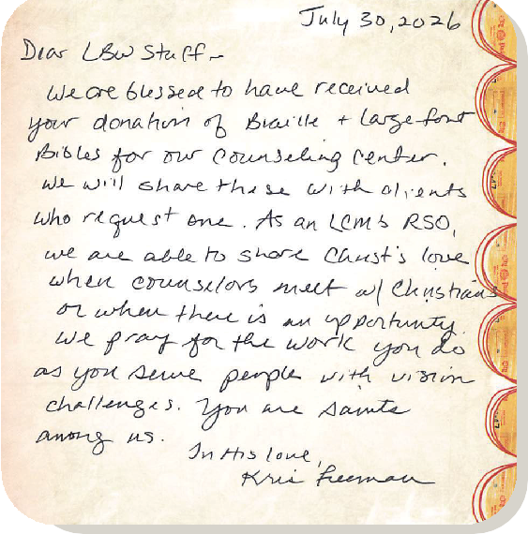
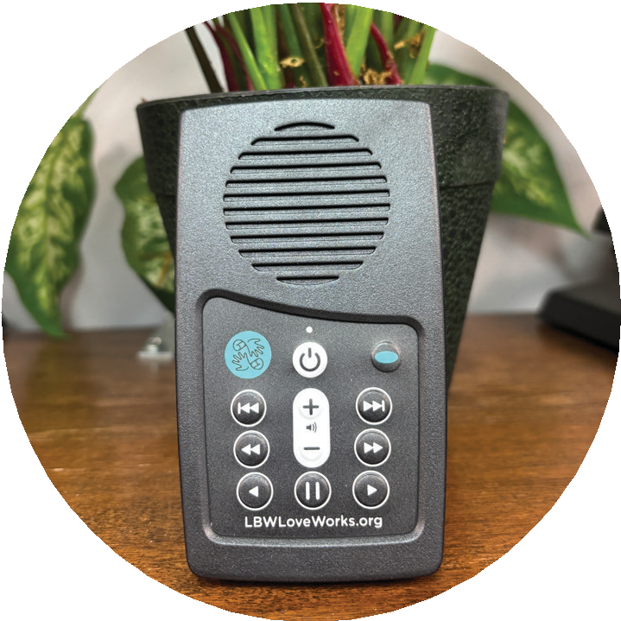
Sometimes sharing God’s Word is as simple as making sure it is available in a way someone can receive it.
Special Thank You
James is 19 years old, loves music, and has Down Syndrome. Recently, he received an audio player from Lutheran Braille Workers filled with God’s Word.
A friend of James’ family shared that since receiving it, he has been listening to the Bible and the other audio content almost nonstop. For a young man who loves to listen, this small player has opened a new way to experience Scripture again and again, whenever he chooses.

From Headquarters

Change in Policy
The Board of Directors of Lutheran Braille Workers recently approved an adjustment to LBW’s donor privacy policy. This change allows the ministry to share limited contact information with approved ministry partners for specific mission-related events or appeals. These partners do not receive or have access to donor data.
This update allows LBW to work with affiliated ministry partners to share information about their mission on a limited, temporary basis. It also helps introduce new individuals to LBW’s events and appeals, including those who may be interested in receiving Braille, Large Print, or Audio materials, or in supporting our ministry.
The policy reads: Lutheran Braille Workers, Inc. collects the following personally identifiable information: name, address, credit and/or debit card information, email address, and phone number. This information is collected and maintained to support donor stewardship, process contributions accurately, provide tax receipts, and communicate meaningful updates about LBW’s mission and impact, unless a donor chooses to opt out of future communications.
LBW is committed to protecting donor privacy and handling personal information responsibly. LBW does not sell donors’ private
information. LBW may share minimum contact information—such as name, mailing address, and email address—with approved strategic ministry partners for specific mission-related communications, as specified in written data-use agreements. LBW does not share financial, payment, or other sensitive donor information with outside organizations
Donors may request at any time that LBW not share their contact information.
Simply email LBW@LBWLoveWorks.org or call (909) 795-8977.

Holiday Schedule
As we move toward fall, we begin to think about the holiday season. The Lutheran Braille Workers headquarters will be closed on the following days for Thanksgiving, Christmas, and New Years.

Holiday | Office Closure Date(s)
Veterans Day | Wednesday November 11, 2026
Thanksgiving | Thursday and Friday November 26-27, 2026
Christmas | Thursday and Friday December 24-25, 2026
New Years Eve | Thursday December 31, 2026
New Years Day | Friday - Monday January 1-4, 2027




page 4
Dear Lutheran Braille Workers,
We held Vacation Bible School at our congregation in Torrington, Wyoming. We used the hymn called, “Wake, Awake - Watching for Jesus.” I thought it would be appropriate to connect our mission to something related to sight and thought of LBW.
I shared wonderful videos from your website with the children. It really helped them understand what an incredible mission LBW is to the Blind and Visually Impaired.
We are honored to be a small part of sharing Christ’s love and Gospel message with a check for the amount the children donated over our 4-day VBS.
Courtney Fiminhac, VBS Director
Our Savior Lutheran Church, Torrington, Wyoming

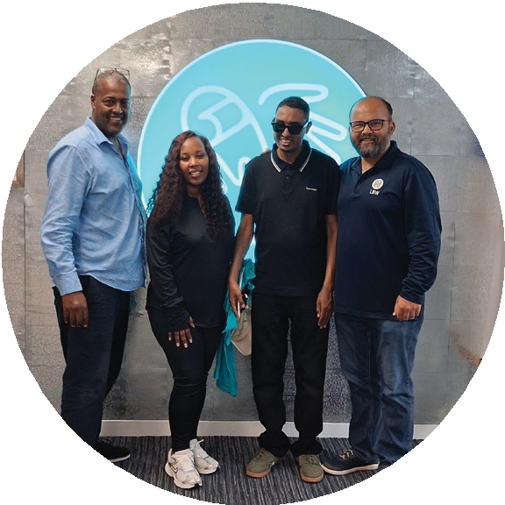
In Remembrance

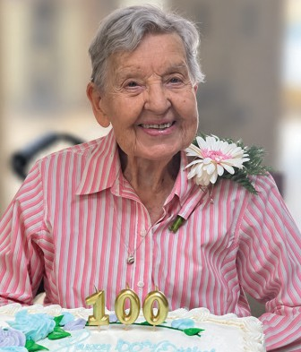
Remembering a Faithful Servant
The Lutheran Braille Workers family is saddened by the passing of longtime volunteer and friend Lovina Werbelow, who died peacefully on September 6 at the remarkable age of 102.
Lovina’s connection to LBW began when she and her husband, Harry, served with the Mobile Missionary Assistance Program (MMAP) and helped build our headquarters in Yucaipa. They eventually made Yucaipa their home, and Lovina became an extraordinary part of the ministry.
From 1998 until 2019, Lovina faithfully volunteered at LBW headquarters. She came in five days a week, helping with the mail before heading to the production area to make and repair books. Her son Warren also worked at LBW, learned to read Braille, and served in our Braille Department. Later he continued volunteering alongside his mom.
Lovina’s service didn’t end when she left the building. She was also a faithful monthly donor and remained a dear friend of LBW after moving to Arizona.
Her obituary describes Lovina as a lifelong volunteer whose life was defined above all by her steadfast faith in Jesus Christ. We are so grateful that more than two decades of that life of service were shared with Lutheran Braille Workers.
We give thanks to God for Lovina, for her faithful hands and generous heart, and for the countless lives touched through her service. Please join us in keeping Warren and the entire Werbelow family in your prayers. Well done, good and faithful servant!

Headquarters Visit

Tewodros Lebryonannes (middle), a blind recipient originating from Ethiopia, received his first Bible at the age of four. As he read it over the years, he dreamed of one day visiting the location printed in its pages—Yucaipa, California. After 30 years, Tewodros finally arrived at our facility, eager to step inside the place that has meant so much to him throughout his life.
Nate guided Tewodros and his two companions on a tour of the facility. They were able to see and feel how the material is made. Jermaine witnessed the joy and excitement as Tewodros described what
it means to be able to touch the Word of God. Tewodros also shared his hope that additional Braille materials can be sent to Ethiopia so that others may have the same opportunity to access Scripture.
Tewodros left with gratitude and a huge smile on his face. He is interested in getting a new Bible in the Amharic language.
What a beautiful reminder that the work done here in Yucaipa reaches lives across the world—and that God’s Word continues to bring hope, joy, and connection to people everywhere.

page 5


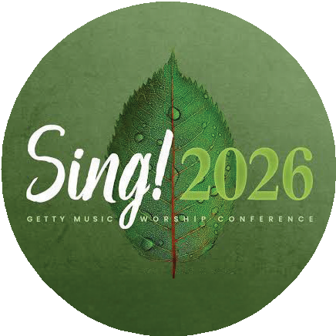
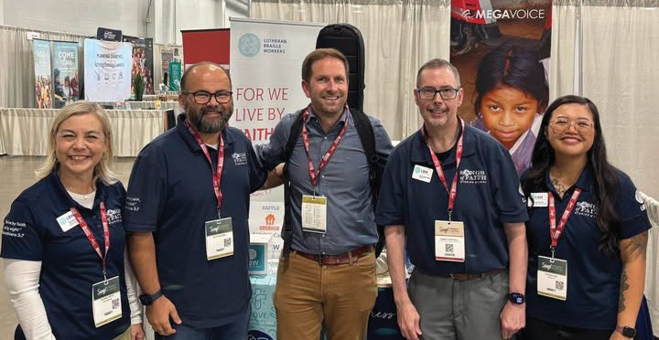
Staff Updates

Intensive Perkins Brailler Training
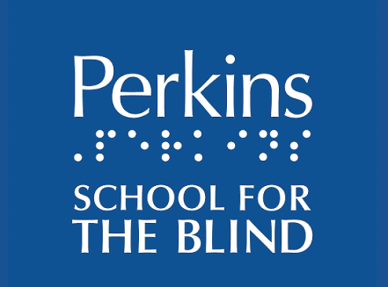
In July, I had the incredible opportunity to attend an intensive Perkins Brailler repair training at Perkins School for the Blind in Watertown, Massachusetts. For many years, Lutheran Braille Workers was fortunate to have dedicated volunteers with the specialized knowledge needed to inspect, maintain, and repair these machines. As those volunteers have stepped away over time, we have gradually lost that internal expertise, leaving a significant gap in a service that is still needed.
Although Perkins Braillers are not commonly used in our own production process, individuals and recipients occasionally contact Lutheran
Braille Workers and send us their personal machines for maintenance or repair. For many braille readers, students, teachers, and families, a Perkins Brailler remains an essential tool for communication, education, and independence. When one stops working, it can be difficult to find
someone with the knowledge and experience needed to properly repair it.
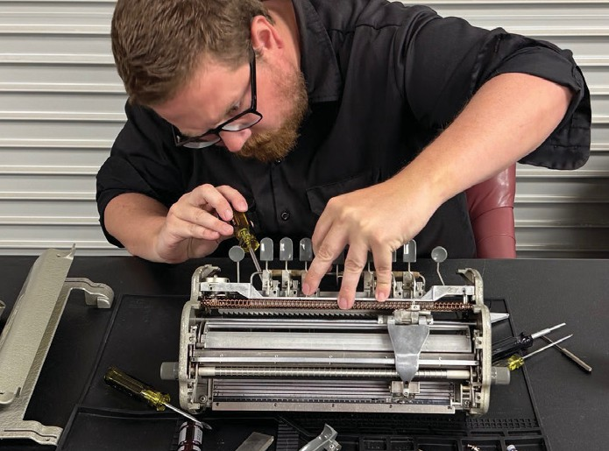

The hands-on training gave me a much deeper understanding of how these machines function, including how to safely disassemble and reassemble them, identify worn or damaged components, and diagnose and correct common mechanical problems. Stepping into this role will allow us to rebuild and preserve this specialized knowledge within the ministry while continuing to provide practical assistance to those who depend on these machines. It is another meaningful way Lutheran Braille Workers can serve the broader blind and visually impaired community beyond just the materials we produce.
Sky Ervin Director of Production & IT

What a week at SING! Conference!
One of the highlights has been sharing Songs of Faith, Stories of Light alongside some of the incredible people helping bring this project to life! We loved spending time with singer-songwriter Blake Flattley, who has been turning the stories of people who are blind or visually impaired into powerful original songs, including our newest release, The Water.
And we’re grateful for our partnership with MegaVoice, helping us put these songs and God’s Word directly into the hands of people who are blind or low vision through accessible audio players.

Great music. Great partnerships. And an even greater mission.

page 6

page 7
Devotion


A verse from John has been appearing and reappearing in my life over the last month.
Do you ever have the experience of having God put a verse of scripture on your heart repeatedly in a short period of time? That has happened to me recently. Over and over again, I have come across the scripture from John 9, the miracle of the blind man. Each time it has surfaced, I have learned something new and gleaned new insight that I have never been exposed to before.
I first came across it in early September. I lead a group of preschool through 3rd grade students in Christ Connections on Sunday Morning. It was a pleasant surprise to discover that the scripture assigned
for that day was John 9. The children shared what they knew about being blind, and we talked about how challenging things must have been for people who were blind during Jesus time. In the passage, the disciples and Jesus come across a blind man sitting on the road. The disciples ask Jesus, “Who has sinned? This man or his parents?” I asked the children why the disciples were asking this. A quiet, shy little kindergartner named Lucy, raised her hand. “Jesus said he wasn’t blind because he did anything wrong,” she quietly said. “His blindness was for the glory of God.”
Later in the same week, I was in St. Louis at our National Campaign Committee Meeting. At that meeting, John 9 was mentioned in our discussion about the people that are served by the ministry of LBW. One of the members, Pastor Bob Newton, spoke up. “In that miracle,” he shared, “Jesus puts mud on the eyes of the blind man and tells him to go and wash in the pool of Siloam. Siloam is a Hebrew word meaning to send out. This was the first time that someone was sent out to show God’s glory to the world through the works of Jesus.”
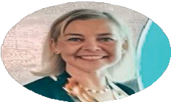
A few weeks later, LBW held an event at headquarters to give updates about the Songs of Faith, Stories of Light Project. Kristin Sukraw from StoryFind talked about the process of interviewing storytellers for the project. She shared that one encounter that touched her deeply was during a conversation with a man who lost his sight later in life. “He was very depressed, and was struggling with the changes in his sight and his life,” she said, “Then he received a Bible from Lutheran Braille Workers. The first book he read was John. When he found John 9:3, he read it over and over. ‘This blindness happened so that the works of God might be displayed in him.’ He said that reading that verse changed his life.”

Written by Rachel Potts
Director of Ministry Relations and
Strategic Partnerships

Jesus answered, “It was neither that this man sinned, nor his parents; but it was so that the works of God might be displayed in him.”
John 9:3 (NASB)

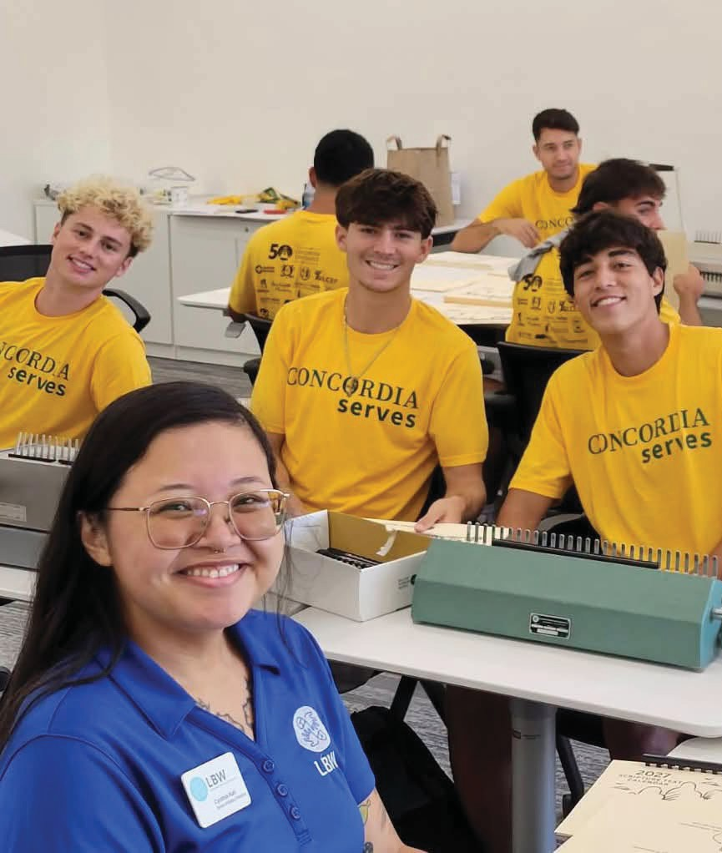
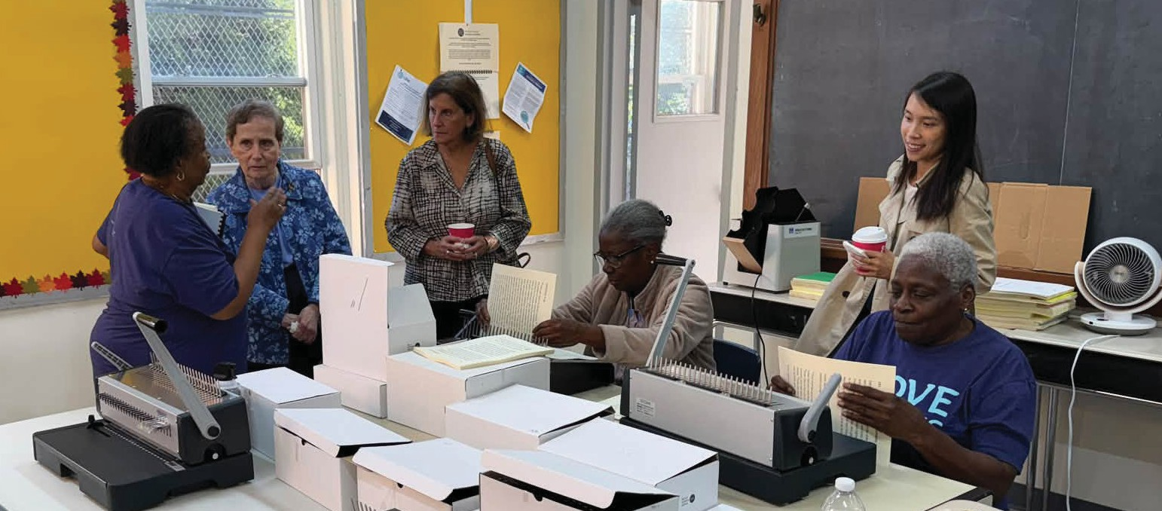
Ministry Updates

Sharing the LBW Ministry
Pastor Tim Roggow of Zion Lutheran Church in Alva, Oklahoma, recently had the opportunity to share the ministry of Lutheran Braille Workers at an LWML Zone Rally.
Zion Lutheran is home to LBW Ministry Production Center #330, where volunteers produce Specialized Large Print Christian materials for people with visual impairments. Pastor Roggow shared the story of how the ministry began in Alva and encouraged the women attending the rally to consider how their own congregations might become involved in making God’s Word accessible.
Following the presentation, a group from Redeemer Lutheran Church in Enid, Oklahoma, visited the Alva Ministry Production Center to see the ministry firsthand and expressed interest in learning more.
We are grateful for Pastor Roggow and the volunteers at MPC #330 for not only faithfully producing accessible Christian materials, but also sharing the ministry with others. One congregation’s “yes” can open the door for another!

Welcoming The Lavelle Fund for the Blind in Brooklyn
Ministry Production Center (MPC) #334 at Saint Paul Lutheran Church in Brooklyn, New York, recently welcomed leaders from The Lavelle Fund for the Blind for a special visit. Guests had the opportunity to experience firsthand the production and distribution process for Lutheran Braille Workers’ Specialized Large Print materials.
The Lavelle Fund for the Blind has been a generous supporter of Lutheran Braille Workers over the years, helping fund important projects such as the purchase of a new Puma Braille embosser and zinc plates used in Braille production. Their generosity has helped strengthen LBW’s ability to produce and distribute accessible Christian materials to people who are blind or visually impaired.
The visit was a wonderful opportunity to showcase the dedication of our volunteers and the important role our Ministry Production Centers play in sharing God’s Word. We are grateful to the volunteers at Saint Paul for welcoming our guests and to The Lavelle Fund for the Blind for their continued friendship, generosity, and commitment to accessibility.

Concordia Serves
On September 23, LBW was blessed to participate in Concordia Serves at Concordia University Irvine! Students and volunteers put their
faith into action by preparing Specialized Large Print calendars and packaging audio players to help share God’s Word with people who are blind or visually impaired.
The amount accomplished was remarkable! In fact, the outgoing mail represented only about one-quarter of the work completed that day. We are grateful to Concordia University Irvine and everyone who generously gave their time to serve others and help bring the hope of God’s Word to those who need it.
page 8

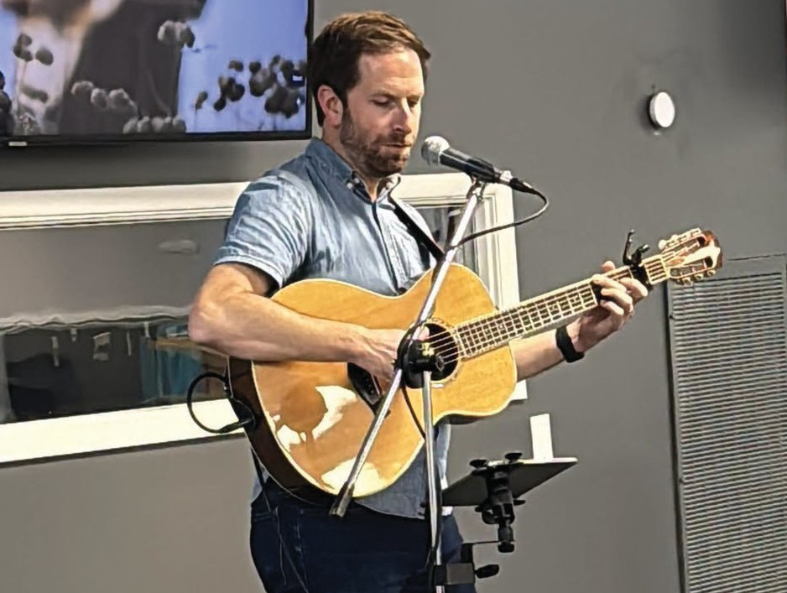
An Evening of Music, Stories, and Fellowship at Lutheran Braille Workers
page 9
On October 6, Lutheran Braille Workers welcomed more than 60 guests to our headquarters in Yucaipa, California, for a special evening of music, storytelling, fellowship, and celebration. The event brought together longtime supporters, ministry partners,
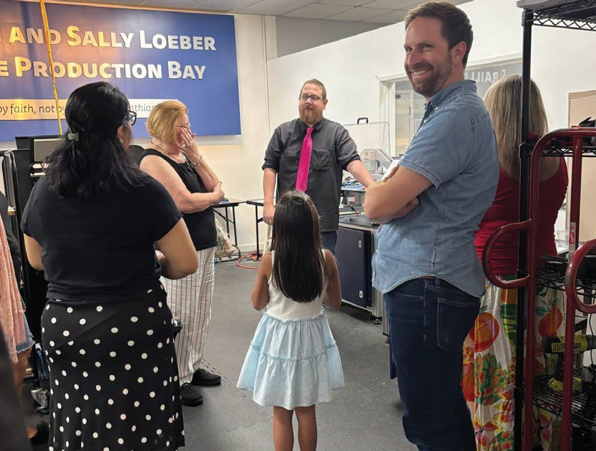
community members, and first-time visitors for an opportunity to experience the mission of LBW and learn more about our newest initiative, Songs of Faith, Stories of Light.
One of the highlights of the evening was a live performance by Christian singer-songwriter Blake Flattley, who shared original music inspired by the faith journeys of individuals who are blind or visually impaired. Guests heard “The Water,” a song inspired by the story of Sharon Luka, who has been blind since birth and whose faith and dedication to sharing God’s Word have touched many lives. Blake also performed “Hope I Don’t Belong,” offering a glimpse into the powerful ways music can communicate personal stories of faith, perseverance, and God’s grace.
Guests also enjoyed special screenings of videos produced through Songs of Faith, Stories of Light, including the stories of Sharon Luka and Shane and Amy Buresh. Through this five-year initiative, made possible by
a grant from Lilly Endowment Inc., LBW is sharing the experiences of individuals who are blind or visually impaired through storytelling, original music, podcasts, and video. The project seeks to amplify voices that are too often overlooked while encouraging Christians to recognize God’s work in the lives of others.
Throughout the evening, guests had opportunities to tour LBW’s headquarters and learn firsthand how Braille and Specialized Large Print materials are produced and distributed. For many first-time visitors, the tours provided a new appreciation for the dedication of thousands of volunteers who help make God’s Word accessible to people around the world. From learning about the history of Braille production to seeing the equipment and processes used today, visitors gained a deeper understanding of the ministry’s impact.
The evening also provided an opportunity to strengthen relationships within the local community. LBW was especially grateful to welcome representatives of the Calimesa Chamber of Commerce and other community partners whose interest and encouragement help connect the ministry with new friends and supporters.
Perhaps most meaningful were the conversations that took place throughout the evening. Guests connected with LBW staff, learned about opportunities to become involved, and discovered how God continues to work through this ministry. The gathering was a reminder that Lutheran Braille Workers is about much more than producing books. It is about sharing the Gospel, building relationships, and ensuring that individuals who are blind or visually impaired have access to God’s Word.




We thank everyone who joined us for this memorable evening, including Blake Flattley, our partners at StoryFind, the Calimesa Chamber of Commerce, and the many friends and supporters who continue to encourage this ministry. We look forward to sharing more stories and songs in the months ahead as Songs of Faith, Stories of Light continues to unfold.



Planning for the Future

Every important project requires the right tools. Estate planning is no different.
One of the most important stewardship decisions we make is determining how the blessings God has entrusted to us will continue to support His purposes after we are called home. A well-designed estate plan allows you to care for your family, express your values, and create a lasting legacy of faith and generosity.
Different goals require different planning tools. For some, a will or trust is the right solution. Others may benefit from a charitable trust, donor-advised fund, personal endowment, or other giving strategy. Each option serves a unique purpose and can help align your resources with the people and ministries you care about most.
The key is choosing the tool that best supports the vision God has placed on your heart. When your plans are guided by purpose and built with the right tools, they can make a meaningful impact for generations to come.
Lutheran Braille Workers partners with trusted organizations, including the LCMS Foundation, Thrivent Charitable, and the Lutheran Legacy Foundation, to help supporters explore the options that best fit their goals and circumstances. These planning tools can provide for loved ones, strengthen local congregations, and advance the mission of Lutheran Braille Workers as we share God’s Word freely with people who are blind or have low vision around the world.
Those who include Lutheran Braille Workers in their estate plans, or who make a gift of $20,000 or more to the LBW Endowment, are welcomed into the Helene Loewe Koehler Light of Christ Legacy Society. Members are recognized annually, unless anonymity is preferred, and receive a commemorative medallion honoring their commitment to helping ensure that the light of Christ continues to shine for generations to come.
To learn more about estate planning opportunities or the Legacy Society, please contact President Hartwell’s assistant, Mrs. Mary Powell, at MaryP@LBWLoveWorks.org.

President’s Challenge
President Hartwell and a faithful group of supporters have pledged $75,000 as a challenge match. This means every dollar you give between now and December 25th will be doubled, up to the matching funds, turning $75,000 in donor gifts into $150,000 for Lutheran Braille Workers’ ministry to produce and distribute Bibles and Christian
resources in Braille, Large Print, Prison Ministry Large Print, and audio at no cost to people who are blind or visually impaired.
Your generosity enables LBW volunteers and staff to continue producing and distributing God’s Word in Braille, Specialized Large Print, and now audio formats, bringing the hope and comfort of Scripture to people who are blind or visually impaired.
Will you accept the President’s Challenge and make a special gift today?
Your gift will be doubled, multiplying its impact and helping God’s Word reach even more people who need it. Join the President’s Challenge by making your fall gift to LBW today. Another Way that “Love Works.”

page 10


Thrivent Choice Dollars and Action Teams
page 11
Lutheran Braille Workers would like to thank Thrivent Financial for the Choice Dollars and the Thrivent Action Team programs. In 2026 to date, we received $22,014.00 from the Choice Dollars, which will help us to continue producing Braille & Large Print, to be given free of charge to anyone who is in need.
Thrivent Action Cards for 2026 have raised $8,500.00, which helps Ministry Centers with their supplies. There are also centers participating in fundraisers with their funds, which raises so much more.
The Thrivent Choice program encourages all members to recommend where Thrivent Financial distributes an amount of its charitable grant funds. Members make this recommendation by directing Choice Dollars to enrolled nonprofit organizations, like Lutheran Braille Workers.

If you are a Thrivent member and have not taken advantage of these programs, please reach out to me with any questions. Deanna Cobb at (909) 795-8977 or deanna@lbwloveworks.org.

If you have allocated your Choice Dollars to LBW and would like your funds to go to your Ministry Center, please call or email Deanna Cobb at (909) 795-8977 or deanna@lbwloveworks.org.

Members now have from January 1 to December 31 to direct their Choice Dollars.
Thank you for all that you do! Blessings always,

Deanna Cobb
Volunteer Relations Coordinator & Accounting Technician



Dear Lutheran Braille Workers,
I wanted you to know that I received the spiral bound book of Mark in Large Print.
Please tell your volunteers that they have found a very good way to serve Christ for those of us who find it hard to read. The font that is used is very good. I am happy I can make notes on the pages.
Before this, I have used my cell phone on the largest font to read the Bible along with others. Now I will have my very own Bible.
Your organization is truly a blessing and God is pleased. Thank you thank you thank you is all I can say. I will pray for this organization to be able to continue to serve those in need.

~


Among LBW’s most faithful correspondents is Dennis from Sierra Madre, California.
Dear LBW,
How are you doing? I am doing just wonderful. Thank you for
from Dennis...
all of the pamphlets you sent me. I really do appreciate you. I hope you’re entertained by my jokes. I hope to hear from you soon!
Sincerely Yours, Dennis
p.s. I have Jesus in my heart as my Lord and Savior.
“
“
“

Notes & Jokes

How did the zombie write his book? He hired a ghost writer.
Why should you never lie to an X-ray technician? Because they can see right through you.
How do cats learn about the world? The evening mews.

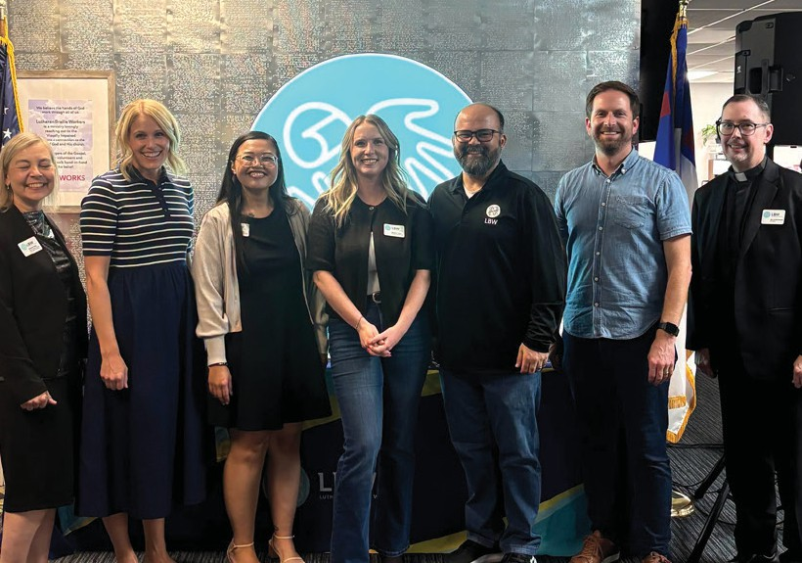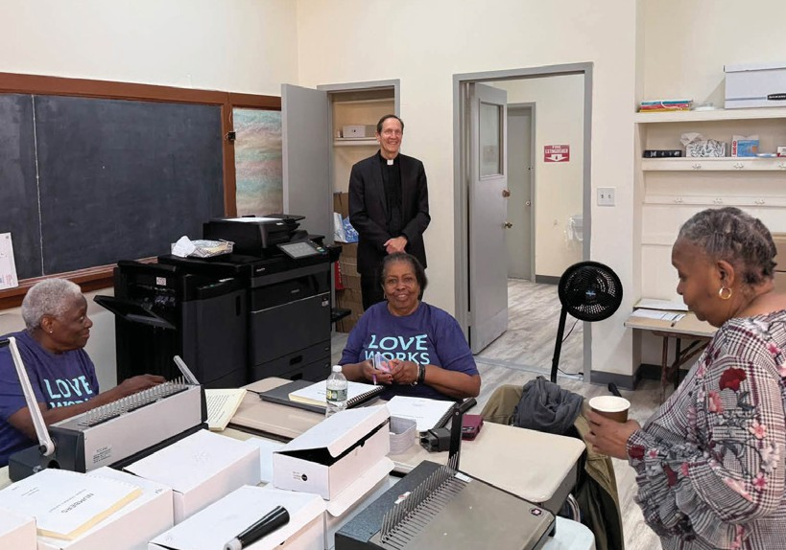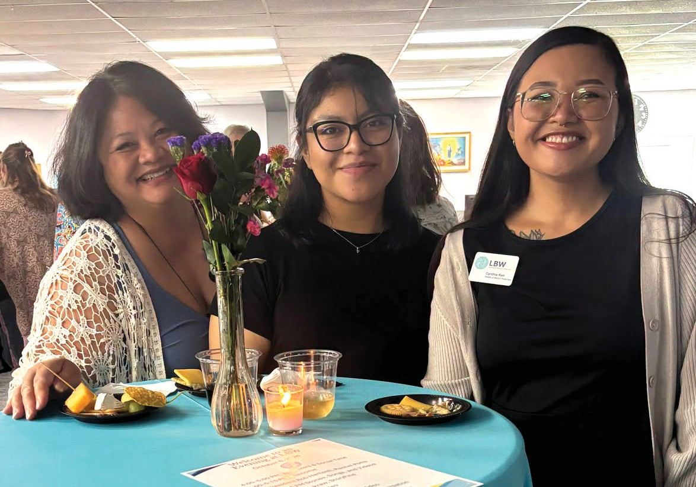

Donate Today or

Scan QR Code to Donate Online

For quick links to our donation page, social media sites, online bookstore, official merchandise, and the LBW website, scan this QR code.



Follow us on social media
@ LutheranBrailleWorkers
@ lbwloveworks



